PA Model – Experiment Progress Report
Nov 12, 2026 · @Sid

Summary
Removing two sources of label noise (quality codes and passenger services) cut false positives at an 80% PA catch rate by about 19%, from ~45.6k to ~36.8k services over the 3-month test period, while catching the same PA. Both changes held on two training seeds.
- Experiments: 4 experiments, 12 registered runs, all scored on one frozen test set (May–Jul 2026, 1.50M services, 47.4k PA services after correction).
- Ranking quality (service AUC-PR): 0.657 → 0.676 (+0.018), same on both seeds.
- At 80% catch rate (recall): precision 44–47% → 51%; false positives 48.2k / 43.1k → 36.6k / 36.9k (seed 42 / seed 7).
- At 75% catch rate: precision 53% → 57%; false positives ~31.9k → ~26.9k (−16%). So 75% recall is achievable, at a score cut-off of about 0.75 and ~57% precision.
- At the current 0.8 score cut-off: 73% of PA services caught (was 72%), with ~1.4k fewer false positives.
- Decision proposed: adopt quality codes excluded + passenger relabel (LABEL_V6_PAX) as the new base. Drop the Acuity denial-code labels (no gain).
Missed PA (FN): with the same number of false alarms as the benchmark, the new model misses 900–1,160 fewer PA services (−10 to −12%), lifting the catch rate from 80% to 82–82.5%.
All figures are service level (CSN + CPT, the prediction unit) on the corrected labels unless marked otherwise; seed 42 / seed 7 shown where both exist.

Data
The 27.5M raw rows (claims std v4, 2022–2026) become 9.4M clean claim lines; the model trains on 7.7M of them and is tested on 1.7M.
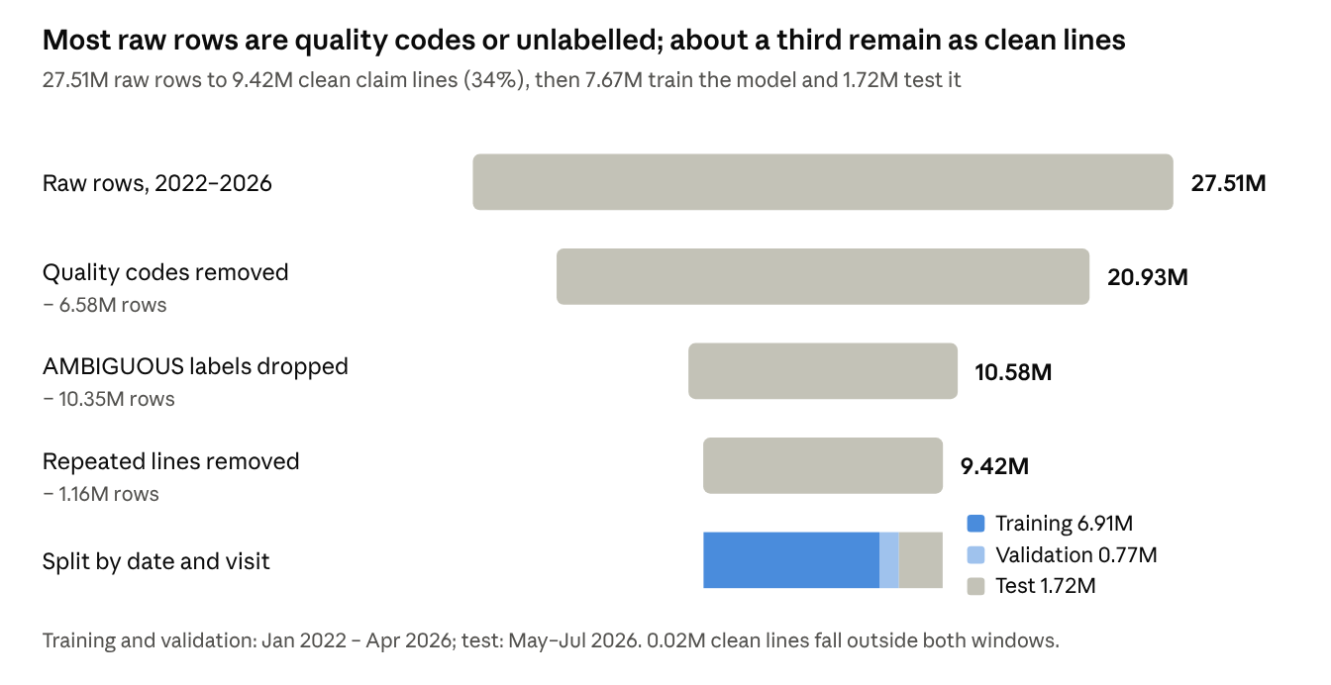
removal_funnel.csv and split_counts.json of run exp_v8d_l6pax_s42 · claims std v4, 2022–2026
The largest losses are quality-code rows (6.58M) and lines whose PA status cannot be determined (10.35M AMBIGUOUS); removing repeats takes another 1.16M.
PA labels (raw lines, all years)
Label version | PA lines | Change
Original (GROUP_LABEL) | 547,317 | –
Quality codes set to not-PA (LABEL_V6) | 526,292 | −21,025 quality-code lines
+ Passenger relabel (LABEL_V6_PAX) | 502,761 | −23,531 passenger lines
Train / validation / test (current best run, LABEL_V6_PAX, seed 42)
Split | Period | Lines | Visits | PA rate (lines)
Training | Jan 2022 – Apr 2026 | 6,908,273 | 3,560,941 | 5.7%
Validation (random 10% of visits) | Jan 2022 – Apr 2026 | 766,707 | 395,661 | 5.8%
Test | May – Jul 2026 | 1,717,478 | 819,665 | 3.1%
Training + validation hold 439,145 PA lines. The frozen official test set, used to score every run, is 1,501,135 services (CSN + CPT) in 819,033 visits: 49,751 PA services on the original labels, 47,411 on the corrected labels (2,340 passenger services differ). A visit is in the test set when its first service date falls in May–Jul 2026.

How the experiments were run
Every change is judged on the same services, the same labels and the same catch rate, and must hold on two seeds before it is adopted.
- Model (fixed): LightGBM, 5 features – CPT, modifier, place of service, payer, plan. Trained on all years (Jan 2022 – Apr 2026), secondary claims included, early stopping on a random 10% of visits.
- Frozen test set: May–Jul 2026, stored with a checksum. Every run is scored on exactly these services.
- Run registry: every run gets an ID that encodes its data, labels, quality-code handling, validation, seed and dates (e.g. pa-lgb5-v8d-l6pax-qcexcl-rv10-s42-y22-26-t2605-2607), plus its settings, code fingerprint and results.
- Two seeds (42 and 7): the seed sets which 10% of visits are used for validation and the random sampling inside LightGBM. A gain counts only if it shows on both. Seed-to-seed noise is about 0.001 AUC-PR and up to ~5k false positives at 80% recall for the benchmark model.
- Same answer key for all models: when labels change, every model is re-scored on both keys – the original labels and the corrected labels – so progress is never a side effect of a changed definition.
- Same catch rate: models are compared at a fixed recall (75%, 80%), where TP and FN are equal by design and only false positives differ.

Two sources of label noise
Analysing the base model's missed PA cases showed that many "PA" labels were not real PA: they were inherited from the claim, not earned by the service.
1. Quality codes (CPT Category II, e.g. 3074F, 1159F)
- $0 reporting codes for quality measures; they never need prior authorization.
- 6.58M of the 27.5M raw rows (24%), rising to 37% of 2025 rows and 31% of 2026 rows. 21,025 of them carried a PA label copied from the claim.
- Fix: removed from training and test (PA_QUALITY_MODE=exclude); in production a quality code is answered "no PA" by rule.
2. Passenger services
- Routine services (office visits such as 99214, G2211, labs, ECG) marked PA only because the claim's auth number is copied onto every line. On 91.7% of multi-CPT visits, every line carries the same auth number.
- Rule: a PA line is a passenger when its auth number is shared with another CPT on the same claim, its CPT is rarely PA on its own (< 2% of lines when alone on a claim), the payer is not a known exception, and another real PA line on the claim owns the auth.
- Fix: 23,531 passenger lines relabelled not-PA (LABEL_V6_PAX). 7,120 lines whose claim has no owning PA line (likely referrals or visit-level auths) were kept PA pending a decision.

Step-by-step progress
Each step lowered false positives at the same catch rate on both seeds; the two steps together remove ~8.9k false positives at 80% recall and ~5.0k at 75%.
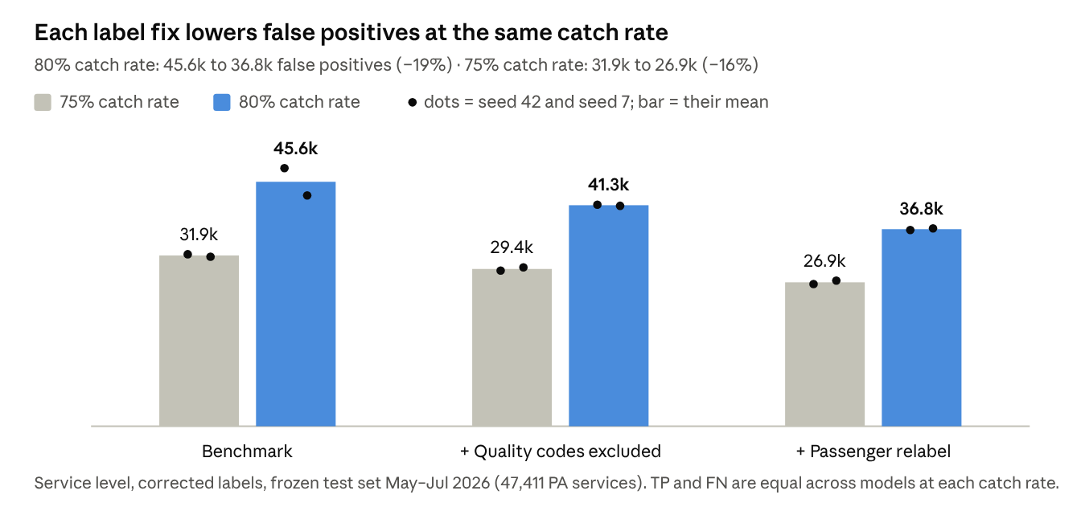
progress_report.py run · frozen test set May–Jul 2026, service level, corrected labels, seeds 42 and 7
The benchmark's false positives vary by ~5k between seeds; the final model's by only ~300, so it is also more stable.
What about missed PA (FN)? At a fixed catch rate FN is equal for every model by design (80% recall = ~9,470 of 47,411 PA services missed), so the improvement shows as fewer false positives. At the fixed score cut-off of 0.8, where FN is free to move, the passenger-relabel model misses fewer PA and raises fewer false positives than the benchmark:
Cut-off 0.8, corrected labels (seed 42 / seed 7) | FN (missed PA) | FP (false alarms)
Benchmark | 13,458 / 13,576 | 25,181 / 25,481
+ Passenger relabel | 12,799 / 13,104 | 24,054 / 23,739
Change | −659 / −472 | −1,127 / −1,742
Same false-alarm budget, fewer misses. Holding false positives at the benchmark's level (its FP at 80% recall), the passenger-relabel model misses about 1,000 fewer PA services:
Seed | FP budget | FN benchmark | FN passenger relabel | Change | Recall
42 | 48,194 | 9,461 | 8,302 | −1,159 (−12%) | 80.0% → 82.5%
7 | 43,103 | 9,479 | 8,577 | −902 (−10%) | 80.0% → 81.9%
From the benchmark's 18,070 FN to 12,799 (cut-off 0.8, seed 42). Most of the drop is the PA definition being corrected; 659 fewer misses come from the better model.
Step | FN at cut-off 0.8 | Change | Type of change
Benchmark as originally reported (test set incl. quality codes, 52,278 PA) | 18,070 | – | –
Same model, quality-code services no longer counted as PA | 15,547 | −2,523 | Definition
Same model, passenger services no longer counted as PA | 13,458 | −2,089 | Definition
New model (quality codes excluded + passenger relabel) | 12,799 | −659 | Model
The 4,612 services removed by the definition changes were never real PA: $0 quality codes and services that only carried another line's auth number. On seed 7 the model step is 13,576 → 13,104 (−472).
Service level, corrected labels (seed 42 / seed 7)
Step | AUC-PR | Precision at 80% recall | Precision at 75% recall | Recall at cut-off 0.8 | FP at cut-off 0.8 | FN at cut-off 0.8
Benchmark | 0.6575 / 0.6572 | 44.1% / 46.8% | 52.5% / 52.9% | 71.6% / 71.4% | 25,181 / 25,481 | 13,458 / 13,576
+ Quality codes excluded | 0.6658 / 0.6659 | 47.8% / 48.0% | 55.0% / 54.5% | 73.6% / 72.8% | 26,250 / 25,622 | 12,534 / 12,897
+ Passenger relabel | 0.6751 / 0.6763 | 50.9% / 50.7% | 57.3% / 56.7% | 73.0% / 72.4% | 24,054 / 23,739 | 12,799 / 13,104
At 80% recall every model catches ~37,940 of 47,411 PA services and misses ~9,470; only the false positives differ.
Service level, original labels (sensitivity check, seed 42 / seed 7)
Step | AUC-PR | FP at 75% recall | FP at 80% recall | Recall at cut-off 0.8 | FN at cut-off 0.8
Benchmark | 0.6447 / 0.6445 | 37,256 / 36,549 | 60,737 / 55,243 | 68.8% / 68.5% | 15,547 / 15,665
+ Quality codes excluded | 0.6527 / 0.6527 | 34,723 / 34,711 | 52,306 / 51,920 | 70.6% / 69.9% | 14,607 / 15,000
+ Passenger relabel | 0.6516 / 0.6527 | 32,398 / 31,734 | 55,868 / 51,703 | 69.6% / 69.0% | 15,113 / 15,421
The original labels still count the 2,340 passenger services as PA, so the passenger model is penalised there by design; even so it has the fewest false positives at 75% recall. The benchmark's often-quoted 18,070 FN was measured at cut-off 0.8 on a different test set that still included quality codes (~65% recall).
Visit level (seed 42). A visit is PA if any service is PA, so the passenger fix leaves visit labels unchanged (23,404 PA visits): visit AUC-PR 0.672 → 0.677 → 0.680, and false-positive visits at 80% recall 21.8k → 20.2k → 18.9k (−13.5%). The benchmark visit figures come from an earlier comparison with a very slightly different scope.

Experiment register
Four experiments, twelve registered runs; two adopted, two dropped.
# | Question | Runs | Result vs previous base | Decision
E1 | How to treat quality codes: keep, label not-PA, or exclude | 5 (keep ×2 seeds, not-PA ×1, exclude ×2) | Exclude: AUC-PR +0.008 on both seeds; bootstrap 200/200 in favour; labelling them not-PA was slightly worse than keeping | Adopted
E2 | Relabel passenger services as not-PA | 3 (v8 sanity run + 2 seeds) | Sanity run reproduced E1 exactly (AUC-PR 0.6527). AUC-PR +0.009 / +0.010 on corrected labels; FP at 80% recall −11% / −10% | Adopt
E3 | Add Acuity auth-only denial codes (10 codes) on top of E2 | 2 | Worse than E2 alone, even scored on its own labels (0.6691 vs 0.6738) | Drop
E4 | Add the full Acuity denial list (17 codes) on top of E2 | 2 | Changes the target to ~2.5× more PA lines, mostly codes 59/16/96 that are not auth codes in X12; own-label AUC-PR only 0.61 | Drop
Earlier exploratory runs (training start year, primary-only vs all claims, time-based vs random validation, diagnosis features, update-on-recent-data, lookup baselines, a payer-rules feature) set up the current configuration but were not scored on the frozen test set, so their figures are not compared here.

How the cut-off is chosen
The model gives each service a score from 0 to 1, and services at or above the cut-off are flagged as needing PA. Lowering the cut-off catches more PA (higher recall) and raises more false positives (lower precision).
- Recall (catch rate) = TP / (TP + FN): the share of real PA services flagged. Precision (hit rate) = TP / (TP + FP): the share of flags that are real PA.
- For comparing models: fixed recall. Each model's scores sit on a slightly different scale, so the same cut-off lands at a different recall. For 80% recall the cut-off is 0.59–0.64 depending on the model; for 75% it is 0.73–0.77. We set each model's cut-off to the same recall and compare false positives.
- Cut-off 0.8 (reference only). It is the cut-off with the best balance of precision and recall (maximum F1, searched in steps of 0.05). It was picked on the test data, so it is slightly optimistic and is not a production setting. At 0.8 the current model catches 73% of PA services with 59% precision.
- For production. The business agrees a target catch rate (for example 75% or 80%); the cut-off that meets it is set on recent validation data and re-set at every retrain, because scores shift when the training data changes.
Answer to "can we reach 75% recall?" Yes. At 75% recall the current model flags ~62k services over the 3-month test period, of which ~35.6k are real PA (57% precision) and ~26.9k are false positives. At 80% recall precision is 51%.

Caveats, open questions and next steps
The label fixes are done; the next gains have to come from features available at prediction time.
Caveats
- The passenger rule is a draft (dataset folder std_data_v8_draft); it needs team sign-off before it becomes the official label.
- The 7,120 visit-level auth lines are still labelled PA, but the new model ranks them low (12.5% above the 80%-recall cut-off vs 28% before). If referrals count as PA, the model under-flags them.
- The PA rate in the test months (3.1% of lines) is about half the training rate (5.7%). Not yet explained; recent claims may not be fully adjudicated. Another reason to set the production cut-off on recent data.
- Two seeds and one test window (May–Jul 2026); gains are consistent but their size is a range, not a point.
Open questions
- ☐ Do referrals (visit-level auths, denial codes 165/243) count as PA? (Raghu, business)
- ☐ What catch rate and precision does the business need? (sets the production cut-off)
- ☐ Does a prediction request carry one service or the whole order/visit? (API team)
- ☐ Which fields are available at prediction time: diagnosis, provider NPI, specialty, product, age, units? (API team)
Next steps
- Sign off quality codes excluded + LABEL_V6_PAX as the new benchmark and register it.
- Rank the candidate pre-visit features by the information they add beyond the current five (existing entropy analysis, add provider NPI, leave out sex and other protected attributes).
- Feature experiments one at a time on the new base: frozen test set, two seeds, registered.
- Push the run registry and the frozen test set to the agreed S3 location.

